WEAKLY-SUPERVISED DEEP EMBEDDING FOR
PRODUCT REVIEW SENTIMENT ANALYSIS

ABSTRACT:
Product reviews are valuable for upcoming buyers in helping them make decisions. To this end, different opinion mining techniques have been proposed, where judging a review sentence’s orientation (e.g. positive or negative) is one of their key challenges. Recently, deep learning has emerged as an effective means for solving sentiment classification problems. A neural network intrinsically learns a useful representation automatically without human efforts. However, the success of deep learning highly relies on the availability of large-scale training data. We propose a novel deep learning framework for product review sentiment classification which employs prevalently available ratings as weak supervision signals. The framework consists of two steps: (1) learning a high level representation (an embedding space) which captures the general sentiment distribution of sentences through rating information; (2) adding a classification layer on top of the embedding layer and use labeled sentences for supervised fine-tuning. We explore two kinds of low level network structure for modeling review sentences, namely, convolutional feature extractors and long short-term memory. To evaluate the proposed framework, we construct a dataset containing 1.1M weakly labeled review sentences and 11,754 labeled review sentences from Amazon. Experimental results show the efficacy of the proposed framework and its superiority over baselines.

ARCHITECTURE:

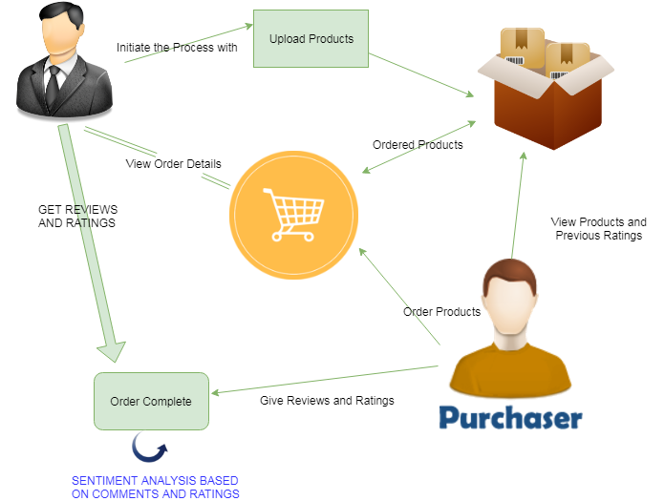

EXISTING SYSTEM:
Lexicon-based methods typically take the tack of first constructing a sentiment lexicon of opinion words (e.g. “wonderful”, “disgusting”), and then design classification rules based on appeared opinion words and prior syntactic knowledge. Despite effectiveness, this kind of methods requires substantial efforts in lexicon construction and rule design. Furthermore, lexicon-based methods cannot well handle implicit opinions, i.e. objective statements such as “I bought the mattress a week ago, and a valley appeared today”. As pointed out in this is also an important form of opinions. Factual information is usually more helpful than subjective feelings. Lexicon-based methods can only deal with implicit opinions in an ad-hoc way.
DISADVANTAGES:
Feature engineering also costs a lot of human efforts, and a feature set suitable for one domain may not generate good performance for other domains. This kind of algorithm needs complex lexicon construction and rule design. The existing systems cannot well handle objective statements; it only handles single word based sentiment analysis.

PROPOSED SYSTEM:
In this work, we propose a novel deep learning framework for review sentence sentiment classification. The framework treats review ratings as weak labels to train deep neural networks. For example, with 5-stars scale we can deem ratings above/below 3-stars as positive/ negative weak labels respectively. The framework generally consists of two steps. In the first step, rather than predicting sentiment labels directly, we try to learn an embedding space (a high level layer in the neural network) which reflects the general sentiment distribution of sentences, from a large number of weakly labeled sentences. That is, we force sentences with the same weak labels to be near each other, while sentences with different weak labels are kept away from one another. To reduce the impact of sentences with rating-inconsistent orientation (hereafter called wrong-labeled sentences), we propose to penalize the relative distances among sentences in the embedding space through a ranking loss. In the second step, a classification layer is added on top of the embedding layer, and we use labeled sentences to fine-tune the deep network. The framework is dubbed Weakly-supervised Deep Embedding (WDE). Regarding network structure, two popular schemes are adopted to learn to extract fixed-length feature vectors from review sentences, namely, convolutional feature extractors and Long Short-Term Memory.
ADVANTAGES:
The Proposed work leverages the vast amount of weakly labeled review sentences for sentiment analysis. It is much more effective than the previously developed works. The proposed work finds the sentiment not only based on the rating that user gives but also taking into consideration of reviews that they are post, In fact mainly takes an account of review, even though user gave ratings

MODULES:
There are five modules divided in this project in order develop the concept of sentiment analysis with tagging. They are listed below
- Products Initiation
- Products acquisition
- Sentiment classification
- Weak Supervision
- Graphical Analysis
MODULE DESCRIPTION:
- Products Initiation
The First phase of the implementation of this project is Products Initiation. In this module admin is uploading the products which user wants to see and purchase. Once admin uploads the product means it stored in the database. The products which are uploaded are listed in website to admin in order to modify or delete the particular product. Admin is the only authorized person to upload the products in this project.
- Products acquisition
The second module of this product conveys that user can view the products which are uploaded by admin. Then they can view the ratings and reviews of the same products which are given by other users who already purchased the product. According to the help of ratings and reviews user can purchase the product. The ordered list is also shown in the project for the convenience of users. The cart and checkout facility is also available to users from this module.
- Sentiment classification
The users who are all purchased the products can rate product as per their interest on one scale of five and they are free to comment for the same. Based on the ratings and reviews given by user sentiment can be analyzed. There are two sentiments maintained in this project they are positive and negative. The equilibrium of rating and the particular comments are noted. In this module of project we implement the algorithm named Sentiment-Analysis-using-Naive-Bayes-Classifier to find the exact sentiment based on the dataset which are predefined.
- Weak Supervision
This module provides the convenience to admin for supervision of the ratings and reviews. It supervises the given rating is high for positive comment or low ratings for negative comments. It shows the admin that how user rated for the products. It shows the comments and rating on the products.
- Graphical Analysis
In this phase of the Implementation user can get the clear picture analysis of the products ratings and reviews. Various factors take into consideration for the graph analysis. In this phase plot the charts like pie graph, bar chart and so others.
ALGORITHM:
In machine learning, naive Bayes classifiers are a family of simple probabilistic classifiers based on applying Bayes' theorem with strong (naive) independence assumptions between the features.
Naive Bayes has been studied extensively since the 1950s. It was introduced under a different name into the text retrieval community in the early 1960s, and remains a popular (baseline) method for text categorization, the problem of judging documents as belonging to one category or the other (such as spam or legitimate, sports or politics, etc.) with word frequencies as the features. With appropriate pre-processing, it is competitive in this domain with more advanced methods including support vector machines. It also finds application in automatic medical diagnosis.
Naive Bayes classifiers are highly scalable, requiring a number of parameters linear in the number of variables (features/predictors) in a learning problem. Maximum-likelihood training can be done by evaluating a closed-form expression, which takes linear time, rather than by expensive iterative approximation as used for many other types of classifiers.
In the statistics and computer science literature, naive Bayes models are known under a variety of names, including simple Bayes and independence Bayes. All these names reference the use of Bayes' theorem in the classifier's decision rule, but naive Bayes is not (necessarily) a Bayesian method
Naive Bayes is a simple technique for constructing classifiers: models that assign class labels to problem instances, represented as vectors of feature values, where the class labels are drawn from some finite set. It is not a single algorithm for training such classifiers, but a family of algorithms based on a common principle: all naive Bayes classifiers assume that the value of a particular feature is independent of the value of any other feature, given the class variable. For example, a fruit may be considered to be an apple if it is red, round, and about 10 cm in diameter. A naive Bayes classifier considers each of these features to contribute independently to the probability that this fruit is an apple, regardless of any possible correlations between the color, roundness, and diameter features.
For some types of probability models, naive Bayes classifiers can be trained very efficiently in a supervised learning setting. In many practical applications, parameter estimation for naive Bayes models uses the method of maximum likelihood; in other words, one can work with the naive Bayes model without accepting Bayesian probability or using any Bayesian methods.
Despite their naive design and apparently oversimplified assumptions, naive Bayes classifiers have worked quite well in many complex real-world situations. In 2004, an analysis of the Bayesian classification problem showed that there are sound theoretical reasons for the apparently implausible efficacy of naive Bayes classifiers. Still, a comprehensive comparison with other classification algorithms in 2006 showed that Bayes classification is outperformed by other approaches, such as boosted trees or random forests.

REQUIREMENT ANALYSIS
The project involved analyzing the design of few applications so as to make the application more users friendly. To do so, it was really important to keep the navigations from one screen to the other well ordered and at the same time reducing the amount of typing the user needs to do. In order to make the application more accessible, the browser version had to be chosen so that it is compatible with most of the Browsers.
REQUIREMENT SPECIFICATION
Functional Requirements
- Graphical User interface with the User.

Software Requirements
For developing the application the following are the Software Requirements:
- Python
- Django
- MySql
- MySqlclient
- WampServer 2.4
Operating Systems supported
- Windows 7
- Windows XP
- Windows 8
Technologies and Languages used to Develop
- Python
Debugger and Emulator
- Any Browser (Particularly Chrome)

Hardware Requirements
For developing the application the following are the Hardware Requirements:
- Processor: Pentium IV or higher
- RAM: 256 MB
- Space on Hard Disk: minimum 512MB

CONCLUSION:
In this work we proposed a novel deep learning framework named Weakly-supervised Deep Embedding for review sentence sentiment classification. WDE trains deep neural networks by exploiting rating information of reviews which is prevalently available on many merchant/review Websites. The training is a 2-step procedure: first we learn an embedding space which tries to capture the sentiment distribution of sentences by penalizing relative distances among sentences according to weak labels inferred from ratings; then a softmax classifier is added on top of the embedding layer and we fine-tune the network by labeled data. Experiments on reviews collected from Amazon.com show that WDE is effective and outperforms baseline methods. Two specific instantiations of the framework, WDE-CNN and WDE-LSTM, are proposed. Compared to WDE-LSTM, WDECNN has fewer model parameters, and its computation is more easily parallelized on GPUs. Nevertheless, WDE-CNN cannot well handle long-term dependencies in sentences. WDE-LSTM is more capable of modeling the long-term dependencies in sentences, but it is less efficient than WDE-CNN and needs more training data. For future work, we plan to investigate how to combine different methods to generate better prediction performance. We will also try to apply WDE on other problems involving weak labels.

