PRICE-BASED RESOURCE ALLOCATION FOR EDGE COMPUTING: A MARKET EQUILIBRIUM APPROACH

ABSTRACT:
The emerging edge computing paradigm promises to deliver superior user experience and enable a wide range of Internet of Things (IoT) applications. In this paper, we propose a new market-based framework for efficiently allocating resources of heterogeneous capacity-limited edge nodes (EN) to multiple competing services at the network edge. By properly pricing the geographically distributed ENs, the proposed framework generates a market equilibrium (ME) solution that not only maximizes the edge computing resource utilization but also allocates optimal resource bundles to the services given their budget constraints. When the utility of a service is defined as the maximum revenue that the service can achieve from its resource allotment, the equilibrium can be computed centrally by solving the Eisenberg-Gale (EG) convex program. We further show that the equilibrium allocation is Pareto-optimal and satisfies desired fairness properties including sharing incentive, proportionality, and envy-freeness. Also, two distributed algorithms, which efficiently converge to an ME, are introduced. When each service aims to maximize its net profit (i.e., revenue minus cost) instead of the revenue, we derive a novel convex optimization problem and rigorously prove that its solution is exactly an ME. Extensive numerical results are presented to validate the effectiveness of the proposed techniques.
ARCHITECTURE:
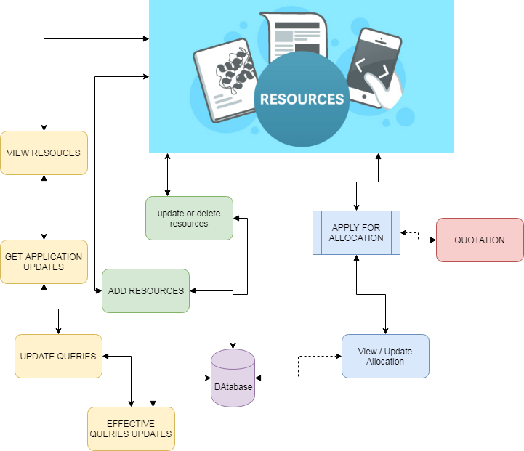

EXISTING SYSTEM:
Different from the existing literature, which mostly deals with optimizing the overall system performance from a single network operator’s point of view, we consider the EC resource allocation problem from the game theory and market design perspectives. In particular, we study how to allocate resources from multiple ENs to multiple services in a fair and efficient way. We exploit the General Equilibrium, a Nobel prize-winning theory, to construct an efficient market-based resource allocation framework. Although this concept was proposed more than 100 years ago, only until 1954, the existence of an ME was proved under mild conditions in the seminal work of Arrow and Debreu. However, their proof based on fixed-point theorem is no constructive and does not give an algorithm to compute equilibrium. Recently, theoretical computer scientists have expressed great interests in understanding algorithmic aspects of the General Equilibrium concept. Various efficient algorithms and complexity analysis for ME computation have been accomplished over the past decade Note that although the existence result has been established, there is no general technique for computing an ME.

PROPOSED SYSTEM:
Our proposed models are inspired by the Fisher market which is a special case of the exchange market model in the General Equilibrium theory. An exchange market model consists of a set of economic agents trading different types of divisible goods. Each agent has an initial endowment of goods and a utility function representing her preferences for the different bundles of goods. Given the goods’ prices, every agent sells the initial endowment, and then uses the revenue to buy the best bundle of goods they can afford. The goal of the market is to find the equilibrium prices and allocations that maximize every agent’s utility respecting the budget constraint, and the market clears. In the Fisher market model, every agent comes to the market with an initial endowment of money only and wants to buy goods available in the market. We cast the EC resource allocation problem as a Fisher market. We not only show appealing fairness properties of the equilibrium allocation, but also introduce efficient distributed algorithms to find an ME. More importantly, we systematically devise a new and simple convex program to capture the market in which money has intrinsic value to the buyers, which is beyond the scope of the classical Fisher market model. Different from the existing works on cloud economics and resource allocation in general, our design objective is to find a fair and efficient way to allocate resources from multiple nodes (e.g., ENs) to budget-constrained agents (i.e., services), which makes every agent happy with her resource allotment and ensures high edge resource utilization. The proposed model also captures practical aspects, for example, a service request can be served at different ENs and service demands can be defined flexibly rather than fixed bundles as in auction models.
ALGORITHM:
DECISION TREE ALGORITHM
Decision tree is the most powerful and popular tool for classification and prediction. A Decision tree is a flowchart like tree structure, where each internal node denotes a test on an attribute, each branch represents an outcome of the test, and each leaf node (terminal node) holds a class label.
Construction of Decision Tree: A tree can be “learned” by splitting the source set into subsets based on an attribute value test. This process is repeated on each derived subset in a recursive manner called recursive partitioning. The recursion is completed when the subset at a node all has the same value of the target variable, or when splitting no longer adds value to the predictions. The construction of decision tree classifier does not require any domain knowledge or parameter setting, and therefore is appropriate for exploratory knowledge discovery. Decision trees can handle high dimensional data. In general decision tree classifier has good accuracy. Decision tree induction is a typical inductive approach to learn knowledge on classification.
Decision Tree Representation: Decision trees classify instances by sorting them down the tree from the root to some leaf node, which provides the classification of the instance. An instance is classified by starting at the root node of the tree, testing the attribute specified by this node, and then moving down the tree branch corresponding to the value of the attribute as shown in the above figure. This process is then repeated for the sub tree rooted at the new node.
MODULES:
- ADD RESOURCE
The resources have been uploading in database in order to view for users. Resources can be uploading, modify or delete. The added resources can be visible to user and user can apply with required details. User can add details with their quotation of application. So that user can implement their work.
- ALLOCATE RESOURCE
The received applications are viewed by admin. Admin then, find the available space and view application and based on that, algorithm applied to sort the best user to be allocated or the allocation space will be measured according to the quotation of user had submitted. The allocated resource can be utilized by user and admin need to intimate the user that how much resource have been allocated.
- USER QUERIES
Users can have queries about the process. This part of project is dedicated to make and get response for queries that are needed to answerable. The major part of the modules is making project as interactive one, queries have been very normally arise to users regarding different details about the process.
- GRAPH ANALYSIS
Graph analysis is the part where admin can knows the statistics about process of details. The data are taken from the project flow and it shows until updated value. The data are gives clear solution to admin that part of improvement and user satisfaction and other factors.

FUTUREWORK:
The proposed framework could serve as a first step to understand new business models and unlock the enormous potential of the future EC ecosystem. There are several future research directions. For example, we will investigate the ME concept in the case when several edge networks cooperate with each other to form an edge/fog federation. Investigating the impacts of the strategic behavior on the efficiency of the ME is another interesting topic. Note that N. Chen has shown that the gains of buyers for strategic behavior in Fisher markets are small. Additionally, in this work, we implicitly assume the demand of every service is unlimited. It can be verified that we can add the maximum number of requests constraints to the EG program to capture the limited demand case, and the solution of this modified problem is indeed an ME. However, although the optimal utilities of the services in this case are unique, there can have infinite number of equilibrium prices. We are investigating this problem in our ongoing work. Also, integrating the operation cost of ENs into the proposed ME framework is a subject of our future work. Finally, how to compute market equilibria with more complex utility functions that capture practical aspects such as task moving expenses among ENs and data privacy is an interesting future research direction. It is also interesting to test the performance of the proposed approach on real datasets of an EC system when EC is widely deployed.
REQUIREMENT ANALYSIS
The project involved analyzing the design of few applications so as to make the application more users friendly. To do so, it was really important to keep the navigations from one screen to the other well ordered and at the same time reducing the amount of typing the user needs to do. In order to make the application more accessible, the browser version had to be chosen so that it is compatible with most of the Browsers.
REQUIREMENT SPECIFICATION
Functional Requirements
- Graphical User interface with the User.
Software Requirements
For developing the application the following are the Software Requirements:
- Python
- Django
- MySql
- MySqlclient
- WampServer 2.4
Operating Systems supported
- Windows 7
- Windows XP
- Windows 8
Technologies and Languages used to Develop
- Python
Debugger and Emulator
- Any Browser (Particularly Chrome)
Hardware Requirements
For developing the application the following are the Hardware Requirements:
- Processor: Pentium IV or higher
- RAM: 256 MB
- Space on Hard Disk: minimum 512MB

CONCLUSION:
In this work, we consider the resource allocation for an EC system which consists geographically distributed heterogeneous ENs with different configurations and a collection of services with different desires and buying power. Our main contribution is to suggest the famous concept of General Equilibrium in Economics as an effective solution for the underlying EC resource allocation problem. The proposed solution produces an ME that not only Pareto-efficient but also possesses many attractive fairness properties. The potential of this approach are well beyond EC applications. For example, it can be used to share storage space in edge caches to different service providers. We can also utilize the proposed framework to share resources (e.g., communication, wireless channels) to different users or groups of users (instead of services and service providers). Furthermore, the proposed model can extend to the multi-resource scenario where each buyer needs a combination of different resource types (e.g., storage, bandwidth, and compute) to run its service. We will formally report these cases (e.g., network slicing, NFV chaining applications) in our future work.

