Trust Agent-Based Behavior Induction in Social Networks

ABSTRACT
The essence of social networks is that they can influence people's public opinions and group behaviors form quickly. Negative group behavior influences societal stability significantly, but existing behavior-induction approaches are too simple and inefficient. To automatically and efficiently induct behavior in social networks, this article introduces trust agents and designs their features according to group behavior features. In addition, a dynamics control mechanism can be generated to coordinate participant behaviors in social networks to avoid a specific restricted negative group behavior. This article investigates the importance of the endogenous selection of partners for trust and cooperation inmarket exchange situations, where there is informationasymmetry betweeninvestors andtrustees.We created an experimental-data driven agent-based model where the endogenous link between interaction outcome and social structure formation was examined starting from heterogeneous agent behaviour. By testing various social structure configurations, we showed that dynamic networks lead to more cooperation when agents can create more links and reduce exploitation opportunities by free riders. Furthermore, we found that the endogenous network formation was more important for cooperation than the type of network. Our results cast serious doubt about the static view of network structures on cooperation and can provide new insights into market efficiency.
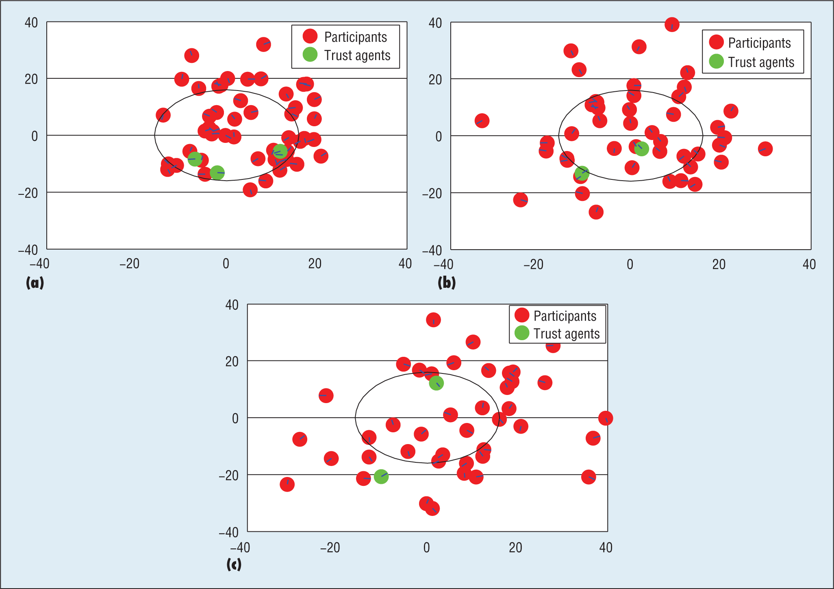
EXISTING SYSTEMS

Online behavioral analysis and modeling has aroused considerable interest from closely related research fields such as data mining, machine learning, and information retrieval. This special issue provides a forum for researchers in behavior analysis to review pressing needs, discuss challenging research issues, and showcase state-of-the-art research and development in modern Web platforms.

Research on network group behavior tendency generally can be divided into two areas: negative tendencies and hot-issue tendencies. For a negative tendency in group behavior, Yiting Zhang explained why violent behavior exists on the Internet and proposed countermeasure research to avoid it.

PROPOSED SYSTEMS

In Proposed systems by focusing on short texts published on social networks, one group of researchers proposed a biterm topic model that learns behavior topics by directly modeling the
generation of word co-occurrence patterns (that is, biterms) in the corpus.

The core problem of behavior induction in this article is as follows: with some restricted behaviors predetermined, how to induct participants in social networks to avoid these behaviors?

There are all kinds of interaction relations between participants in social networks, but the most important one is trust. Abstractly, trust is the measure taken by one party about the willingness and ability of another party to act in the interest of the former party in a certain situation.

However, there’s still no research on trust related to behavior induction in social networks—in particular, how to design features that make trust agents trusted by participants, maximize the effect of participant behaviors, and enhance the effectiveness of behavior induction.

IMPLEMETATION
Module Description
1.Behavior Induction in Social Networks
2. Trust Agent Feature Selection
3. Trust Agent-Based Behavior Induction

1.BEHAVIOR INDUCTION IN SOCIAL NETWORKS

The core problem of behavior induction in this article is as follows: with some restricted behaviors predetermined, how to induct participants in social networks to avoid these behaviors?

A participant’s behaviors can be mined from what he or she has posted on various social networks such as Twitter. For example, by focusing on short texts published on social networks, one group of researchers proposed a biterm topic model that learns behavior topics by directly modeling the generation of word co-occurrence patterns (that is, biterms) in the corpus. Without a loss of generality, we only take one behavior br as the element in the set of restricted behaviors
as an example to illustrate our induction approach.

Group Behavior Tendency in Social Networks

Group behavior tendency—that is, public opinion—is a publicly released, generally agreed upon attitude or opinion about a certain social incident by the general public under a specified time and space.1 Network group behavior tendency is a set of all attitude, affection, and behavior tendencies on a certain event that are spread over the Internet.

Current research on group behavior tendency mostly focuses on politics, sociology, journalism, and related social science disciplines. In politics, many studies on group behavior tendency focus on democratic elections.

In sociology and journalism, research on network group behavior tendency generally can be divided into two areas: negative tendencies and hot-issue tendencies. For a negative tendency in group behavior, Yiting Zhang explained why violent behavior exists on the Internet and proposed countermeasure research to avoid it. The research on hot issue group behavior tendencies includes network text analysis and topic detection techniques that cover topic tracking, hot-topic detection and retrieval, network property analysis, and public opinion propagation.

Social Network Behavior Formation Analysis

In social network behavior formation analysis, traditional analysis approaches can’t accurately describe features such as strong interaction evolution and public emotional drift in large-scale online social networks.

Peng Cui and colleagues8 were the first to investigate the problem of cascading outbreak prediction and propose a novel data driven approach to identify the key users whose behaviors
were highly correlated with information outbreaks.

Social Network Behavior Interaction Analysis

There are all kinds of interaction relations between participants in social networks, but the most important one is trust. Abstractly, trust is the measure taken by one party about the willingness and ability of another party to act in the interest of the former party in a certain situation.12 If the trust value is in the range of [0, 1], it can be taken as the subjective probability with which one party expects that another party performs a given action. Since the pioneering work by Stephen
Marsh, the issue of trust has attracted much attention in the field of information technology, where researches mostly focus on a target entity’s security, the relation between participants, and the influence on trust relations. The ultimate goal is to obtain objective results about effective approaches.

2.TRUST AGENT FEATURE SELECTION

Trust agents’ social features can be selected according to participants’ social features. This encourages participants to trust the agents, and then follow the agents’ designed behaviors.

Social features describe context—in this case, a participant’s social environment in a social network8 and can be classified into independent and dependent social features.

A participant’s independent social features refer to the personal characteristics that influence his or her interactions, trust, and recommendations; they typically include a role impact factor and preference. Participant activities in social networks can be categorized into different domains based on their characteristics, which we consider the role impact factor. For example, the behavior of a person who has expertise in a particular domain is deemed more trustworthy than that of someone who has no knowledge in it.

Some social networks only consider dependent social features, such as anonymous social networks, which can be called behavior feature-driven social networks, whereas some social networks consider both independent and dependent social features, which can be called mixed feature-driven social networks.

3.TRUST AGENT-BASED BEHAVIOR INDUCTION

After trust agents’ social features are selected to make participants trust the agent, the agent’s designed behaviors can effectively induct participant behaviors through the following steps:

1. Initialize the average probability RAgt of all trust agents entering the restricted behavior area in a behavior- mapping space as the average probability R of all participants entering the restricted behavior area. Initialize the average probability QAgt of all trust agents leaving the restricted behavior area in the behavior- mapping space as the average probability Q of all participants leaving the restricted behavior area.
2. Define the initial induction time as t0, when participants in the restricted behavior area reach the threshold Z. Define q time units as qt. Initialize q = 1.

3. With Equations 1 and 2, at time T = t0 + qt, the probability of all trust agents entering and leaving the restricted behavior area is
R^{t0+q}_{Agt} and Q^{t0} ^{+q}_{Agt}

where g is the induction factor, which is specified in the system users’ preferences or fulfilled by domain experts.

4. If the number of participants in a restricted behavior area pr is less than a threshold L, the induction is completed; otherwise, assign the value of q + 1 to and q go to step 3.

SYSTEM SPECIFICATION
Hardware Requirements:

- System : Pentium IV 3.5 GHz or Latest Version.
- Hard Disk : 40 GB.
- Monitor : 14’ Colour Monitor.
- Mouse : Optical Mouse.
- Ram : 1 GB.

Software Requirements:

- Operating system : Windows XP or Windows 7, Windows 8.
- Coding Language : Java / J2EE (Jsp,Servlet)
- Data Base : My Sql Server
- Documentation : MS Office
- IDE : Eclipse Galileo
- Development Kit : JDK 1.6
- Server : Tomcat 6.0

CONCLUSION
Now that we’ve proposed and experimentally validated our trust agent-based social behavior induction approach. In future work we’ll introduce Latent Dirichlet Allocation to abstract the behavior features of users in social networks, such as Twitter. We can construct links in behavior feature-driven social networks using the Pearson similarity of users’ behavior features.The explicit formulation of trust, reputation, and related quantities suggests a straightforward implementation of the model in a multi-agent environment.

