REVIEW OF THE USE OF AI TECHNIQUES IN SERIOUS
GAMES: DECISION-MAKING AND MACHINE LEARNING

ABSTRACT:

The video-games market has become an established and ever-growing global industry. The health of the videoand computer games industry, together with the variety of genres and technologies available, mean that videogameconcepts and programs are being applied in numerous different disciplines. One of these is the field known asserious games. The main goal of this article is to collect all the relevant articles published during the last decadeand create a trend analysis about the use of certain artificial intelligence algorithms related to decision making andlearning in the field of serious games. A categorization framework was designed and outlined to classify the 129papers that met the inclusion criteria. The authors made use of this categorization framework for drawing some conclusions regarding the actual use of intelligent serious games. The authors consider that over recent years enoughknowledge has been gathered to create new intelligent serious games to consider not only the final aim but also thetechnologies and techniques used to provide players with a nearly real experience. However, researchers may needto improve their testing methodology for developed serious games, so as to ensure they meet their final purposes.

EXISTING SYSTEM:

There are numerous studies about Finding and Setting the Trend in Use of the AI Techniques in serious games. The main purpose of a serious game is both to be fun and entertaining, and educational. A serious game is thus designed both to be attractive and appealing to a broad target audience, and to meet specific educational goals. They are designed to foster knowledge, skills or routine habits in the player. The existing systems are not setting the current trends. This will find and predict the current trend in the gaming world.This article consist of an analysis of serious games, offering a literary review of their use combined with certain artificial intelligence techniques in the area of decision making and machine learning. Other areas such as pathfinding were initially considered for study but were not sized enough for further analysis, so they were excluded from this review. The article is divided into several sections. First of all, a complete methodology is introduced presenting the form and function of data collected from the literature review. Then, each of the following subsections presents a contextualization and classification of available articles. Finally, the article ends with the discussion and conclusion section.

PROPOSED SYSTEM:
The Proposed system is finding the best algorithm technique to design and develop the serious games. The Best Decision Making and machine learning algorithms are found to use in the serious games design which supports the developer to do it effective way. AI techniques were applied with a wide variety of final. The most common implementations were for altering the game flow or for assessing/classifying users’ state and behavior while playing. The productions of intelligent serious games that dynamically adapt themselves to users’ needs and performance have been proved to be efficient in terms of improvement comparisons.

ARCHITECTURE:
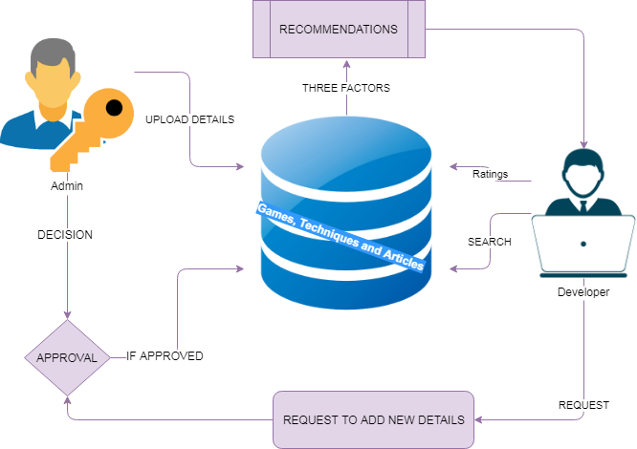

MODULES:

- UPLOAD AND SEARCH GAMES AND TECHNIQUES

This is admin side module. Admin Uploads the Games, Algorithm techniques and Technical Articles. The uploaded details were maintained in database. Developer can view the details by searching all over the details. The technical details are listed in the Developers window which is very useful for them to get to know about the current technologies and details used in other developers of same knowledge.

- RECOMMENDATIONS

The Recommendation is set the trend in the gaming world of development. The Recommendations are based on three factors which is listed follows. Based on usage of algorithms in industry, Based on the Technical Articles Presented and Ratings and Reviews of the Developer in the systems. These recommendations are given to developer to set the industry trends.
- REQUEST FOR ADD

In this module add the developer technical details based on their wish. Once the developer is request admin to add their details to database. The admin can view the details of the users and they can take the decision on the developer’s request weather the details should add to the database. The Details will be added and take account of the recommendation details.

- RATINGS AND REVIEWS

The Ratings and reviews are given to the recommend or used techniques. The Details were taken into the consideration to add the recommendation system and get the feedback of how technology is used and effective and userfriendly.

ALGORITHM:

DECISION TREE LEARNING

Decision tree learning uses a decision tree (as a predictive model) to go from observations about an item (represented in the branches) to conclusions about the item's target value (represented in the leaves). It is one of the predictive modeling approaches used in statistics, data mining and machine learning. Tree models where the target variable can take a discrete set of values are called classification trees; in these tree structures, leaves represent class labels and branches represent conjunctions of features that lead to those class labels. Decision trees where the target variable can take continuous values (typically real numbers) are called regression trees.
In decision analysis, a decision tree can be used to visually and explicitly represent decisions and decision making. In data mining, a decision tree describes data (but the resulting classification tree can be an input for decision making). This page deals with decision trees in data mining.
Decision tree learning is a method commonly used in data mining.^{[1]} The goal is to create a model that predicts the value of a target variable based on several input variables. An example is shown in the diagram at right. Each node corresponds to one of the input variables; there are edges to children for each of the possible values of that input variable. Each leaf represents a value of the target variable given the values of the input variables represented by the path from the root to the leaf.
REQUIREMENT ANALYSIS
The project involved analyzing the design of few applications so as to make the application more users friendly. To do so, it was really important to keep the navigations from one screen to the other well ordered and at the same time reducing the amount of typing the user needs to do. In order to make the application more accessible, the browser version had to be chosen so that it is compatible with most of the Browsers.
REQUIREMENT SPECIFICATION
Functional Requirements
- Graphical User interface with the User.

Software Requirements
For developing the application the following are the Software Requirements:
- Python
- Django
- Mysql
- wampserver

Operating Systems supported
- Windows 7
- Windows XP
- Windows 8
Technologies and Languages used to Develop
- Python
Debugger and Emulator
- Any Browser (Particularly Chrome)
Hardware Requirements
For developing the application the following are the Hardware Requirements:
- Processor: Pentium IV or higher
- RAM: 256 MB
- Space on Hard Disk: minimum 512MB

CONCLUSION:
Finally, the authors consider that over recent years enough knowledge has been gathered to create new intelligent serious games to consider not only the final aim but also the technologies and techniques used to provide players with a nearly real experience. This new age of serious games is very close to the world of video-games, and they generate new solutions completely adapted to their target audience. However, researchers may need to improve their methodology for testing developed serious games, so as to ensure they meet their final purposes. Moreover, the authors would like to encourage other researchers to extend this article to other AI specific techniques and/or addressing new AI-related features, to extend this state of the art in the field of serious games, creating a knowledgehub for researchers in the area.

