DATA-DRIVEN DESIGN OF FOG COMPUTING AIDED PROCESS MONITORING SYSTEM FOR LARGE-SCALE INDUSTRIAL PROCESSES

ABSTRACT:
Stimulated by the recent development of fog computing technology, in this paper, a fog computing aided process monitoring and control architecture is proposed for large-scale industrial processes, which enables reliable and efficient online performance optimization in each fog computing node without modifying pre-designed control subsystems. Moreover, a closed loop data-driven method is developed for the process monitoring system design and an adaptive configuration approach is proposed to deal with the problems caused by the changes of process parameters and operating points. The feasibility and effectiveness of the proposed design approaches are verified and demonstrated through the case study on the Tennessee Eastman (TE) benchmark system.

ARCHITECTURE:
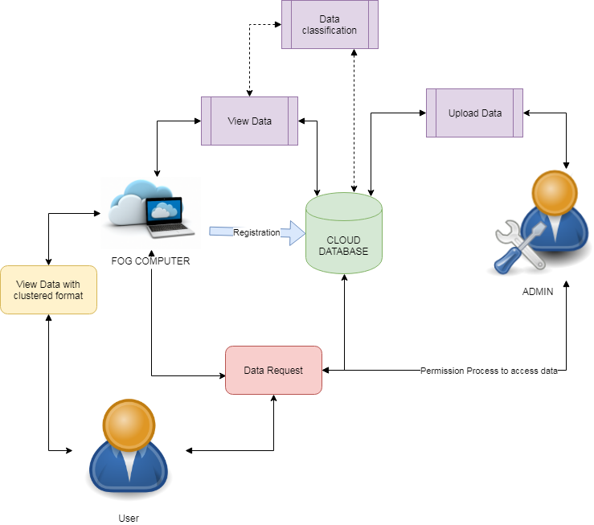
EXISTING SYSTEM:
The existing data-driven designs result in a central computing procedure where the global information is needed. For a large-scale industrial process, the whole design thus involves huge computational and communicational burden, especially when an online configuration of the designed monitoring and control systems is demanded. In order to release the central computational burden and reduce the communication efforts among isolated subsystems, the decentralized monitoring and control technologies, and the references therein, could be utilized.
PROPOSED SYSTEM:
In this paper, motivated by the advantages brought by fog computing technique, a fog computing aided process monitoring and control architecture is firstly proposed for large-scale industrial processes. Differing from the existing decentralized monitoring and control strategies, the proposed one avoids the modification of pre-designed control systems and enables online performance optimization in each fog computing node with stability guarantee. In addition, a data-driven design method is developed for the process monitoring system in which the effects of the local feedback system on the process data are considered. Moreover, an adaptive configuration approach is proposed for the designed data-driven process monitoring system in each fog computing node to deal with the problems caused by the changes of process parameters and operating points.
ALGORITHM:
K-MEANS CLUSTERING ALGORITHM
k-means clustering is a method of vector quantization, originally from signal processing, that is popular for cluster analysis in data mining. k-means clustering aims to partition n observations into k clusters in which each observation belongs to the cluster with the nearest mean, serving as a prototype of the cluster. This results in a partitioning of the data space into Voronoi cells. The problem is computationally difficult (NP-hard); however, there are efficient heuristic algorithms that are commonly employed and converge quickly to a local optimum. These are usually similar to the expectation-maximization algorithm for mixtures of Gaussian distributions via an iterative refinement approach employed by both k-means and Gaussian mixture modeling. Additionally, they both use cluster centers to model the data; however, k-means clustering tends to find clusters of comparable spatial extent, while the expectation-maximization mechanism allows clusters to have different shapes. The algorithm has a loose relationship to the k-nearest neighbor classifier, a popular machine learning technique for classification that is often confused with k-means due to the k in the name. One can apply the 1-nearest neighbor classifier on the cluster centers obtained by k-means to classify new data into the existing clusters. This is known as nearest centroid classifier or Rocchio algorithm.
MODULES:
- UPLOAD DATA
The data can be uploaded by admin without any particular scenario but with the details of data. The most importantly large amount of can be handled in order to do practically. The data that are handling throughout the project can be done in this module. Users have permission to view data but not edit the data in online they can request the user to get the data.
- CLASSIFICATION USING ALGORITHM
The data can be categorized by the k means clustering algorithm based on the some scenarios. The data can be cluster with various factors in order to get data properly. The k-means clustering algorithm is applied on the large scale data to access the details in perfect manner.
- PROCESS MONITORING
In this phase of project uploaded data can be monitors that mean data can be visible to all users and access details. The details of data driven details can be monitored to maximum utilization of fog computing technique. The main process to effectively coordinate the data in particular order.
- GRAPH ANALYSIS
Data can be analyzed with the help of graphs like pie chart, bar chart or line chart. This will brings the efficiency of the proposed system in which it gives the broad difference in the proposed system. The data driven methods are applied to large data.
FUTURE WORKS:
In future works it is very effectively utilize the concepts of fog computing aided process monitoring system design of data-driven methods. For our purpose, the residual of the overall process rall;k can be used for process monitoring while the control performance optimization can be achieved by feeding rall;i;k back to i- th control subsystem. It should be noticed that, between the fog computing node and the fog fusion center, only necessary information (i: e: the residual signals, etc.) is exchanged. A general structure of the proposed fog computing aided process monitoring and control architecture is illustrated.
REQUIREMENT ANALYSIS
The project involved analyzing the design of few applications so as to make the application more users friendly. To do so, it was really important to keep the navigations from one screen to the other well ordered and at the same time reducing the amount of typing the user needs to do. In order to make the application more accessible, the browser version had to be chosen so that it is compatible with most of the Browsers.
REQUIREMENT SPECIFICATION
Functional Requirements
- Graphical User interface with the User.

Software Requirements
For developing the application the following are the Software Requirements:
- Python
- Django
- Mysql
- Wampserver

Operating Systems supported
- Windows 7
- Windows XP
- Windows 8
Technologies and Languages used to Develop
- Python
Debugger and Emulator
- Any Browser (Particularly Chrome)
Hardware Requirements
For developing the application the following are the Hardware Requirements:
- Processor: Pentium IV or higher
- RAM: 256 MB
- Space on Hard Disk: minimum 512MB

CONCLUSION:
In this paper, a fog computing aided process monitoring and control architecture is proposed for large-scale industrial processes. To cope with the problems caused by the changes of process parameters and operating points, a closed-loop data driven method is developed for the process monitoring system design and an adaptive configuration approach is proposed. The proposed fog computing aided process monitoring and control architecture effectively saves online computational load and reduces communicational efforts, where the feasibility and effectiveness are verified and demonstrated through the case study on the TE benchmark.

